 |  |  |  | CanoeKayak Canada Whitewater  Emergency Action Plan
LOCATION : Crowsnest River Blairmore run |  |  | DATE :
TIME IN : |  |  | TIME OUT :
TRIP LEADER : |  |  | ASSIST. LEADER :
FIRST AID LEADER :
COMMUNIC. LEADER :

Map of River and Surrounding Area

RIVER ACCESS POINTS : SPECIAL HAZARDS
PUT-IN & TAKE-OUT ] /// DIFFICULT RESCUE AREA(S) >S SIL (INCLUDE DIFFICULTY I TO V)
][ BRIDGE [W WATERFALL (INCLUDE HEIGHT) … DIRECTION OF WATER FLOW
]D DAM P PORTAGE (INCLUDE DISTANCE)
PAVED ROAD (INCLUDE NUMBER) OTHERS (I.E.GLASS ON TRAIL) OTHER IMPORTANT DETAILS
DIRT ROAD H DIRECTION TO HOSPITAL
TRAIL RIVER CLASSIFICATION Ph PAY PHONE
+++++ RAILWAY TRACKS =>R RAPID (INCLUDE DIFFICULTY RI TO RVI) EVACUATION OPTIONS (INCLUDE
A BRIEF DESCRIPTION OF CONDITIONS)
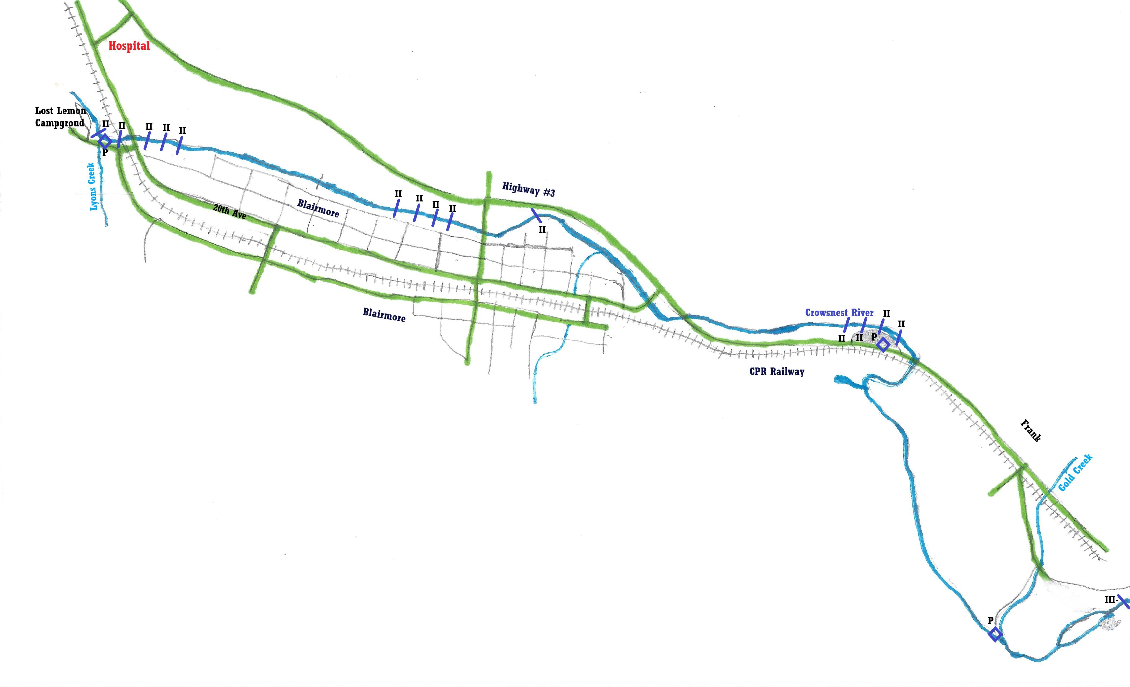
PARTICIPANTS :
NAME MEDICAL ISSUES E.C.P. & CONTACT NUMBERS
__________________________________ ____________________________ ___________________________________

__________________________________ ____________________________ ___________________________________

__________________________________ ____________________________ ___________________________________

__________________________________ ____________________________ ___________________________________

__________________________________ ____________________________ ___________________________________

__________________________________ ____________________________ ___________________________________

__________________________________ ____________________________ ___________________________________

__________________________________ ____________________________ ___________________________________
VEHICLES :
MODEL LICENSE PLATE LOCATION OF KEYS
____________________ ___________________________ _______________________

__________________________________ ____________________________ ___________________________________
IN CASE OF EMERGENCY
1) ENSURE SELF SAFE
2) ENSURE NO OTHERS IN DANGER
3) ALL PADDLERS STOP & MEET
a) EXTRACT VICTIM
4) STABILIZE VICTIM (USE SOAP NOTES)
- LEVEL OF CONSCIOUSNESS
- BREATHING
- CIRCULATION
- C-SPINE
- DISABILITY (NEUROLOGICAL)
- EXTREMITY TRAUMA & EXPOSURE
5) FIRST AID KITS (TREAT VICTIM AS NEEDED)
6) EMERGENCY CONTACT – 911 OR OTHER: NAME NUMBER ADDRESS
- HOSPITAL: Crowsnest Hospital ________ 403-562-5011 2001 – 107 St, Blairmore
- PADDLE ORG:
- PARKS

7) LOCATION OF CELL PHONES : NUMBER OWNER LOCATION

8) LOCATION OF PAYPHONES: ________________________ __________________________________

9) EVACUATION – PREPARATION OF :
- 1- PADDLER IN NEED OF CARE ;
- 2- REQUIRED GEAR
10) GROUP MAINTENANCE

